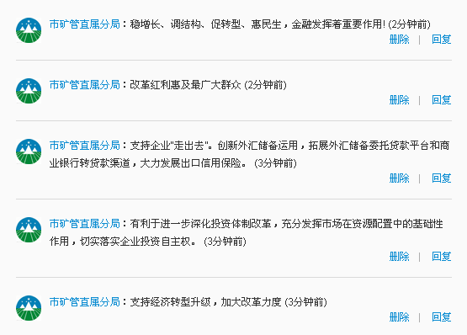http://weibo.com/u/2636715591#_rnd1371710359705

