市矿管局直属分局“两会”跟帖情况

网络评论员：温艳
http://bbs.gndaily.com/home.php?mod=space&do=thread&view=me&type=reply
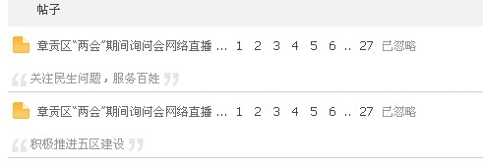
http://bbs.gndaily.com/home.php?mod=space&uid=197840&do=thread&view=me&type=reply&from=&filter=
