牛岭社区清明节网上跟帖4.10
1 http://weibo.com/3817381137/ADbpiEc6v#_rnd1397117106904

2 http://weibo.com/3880516376/ADeDu1iij#_rnd1397117531149
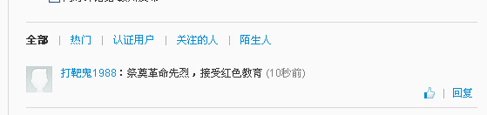
3 http://red.newskj.com/qinming/html/42/743.htm
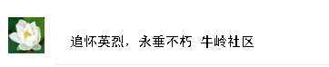
4 http://weibo.com/3880516376/ADeDu1iij#_rnd1397118927343
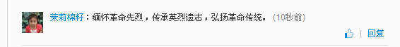
5 http://huati.weibo.com/k/%E7%BC%85%E6%80%80%E5%85%88%E7%83%88+%E6%B8%85%E6%98%8E%E7%A5%AD%E5%A5%A0?from=501
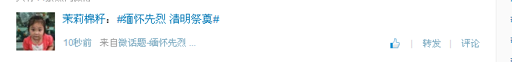
6 http://red.newskj.com/qinming/html/42/743.htm
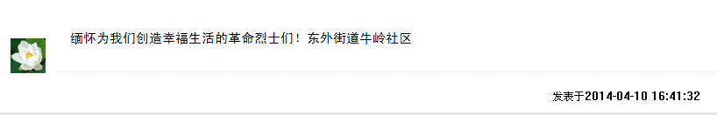
7 http://red.newskj.com/qinming/html/42/743.htm
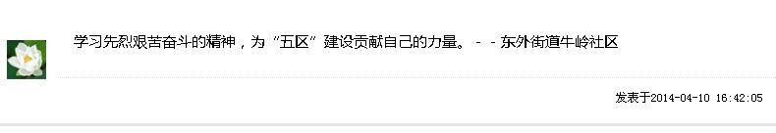
8 http://weibo.com/p/1001063880516376/weibo?from=page_100106&mod=TAB#_rnd1397119573534
