1. 

2. http://weibo.com/3015217697/profile?topnav=1&wvr=5支持~加油
3. 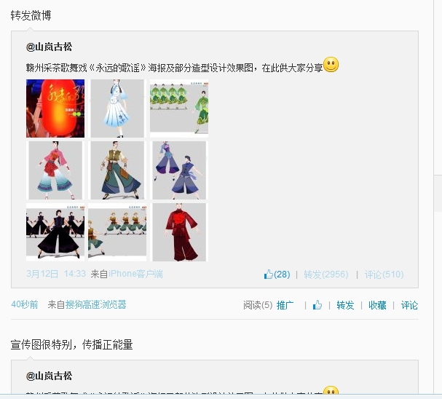
4. http://weibo.com/5047833212/profile?rightmod=1&wvr=5&mod=personinfo
5. 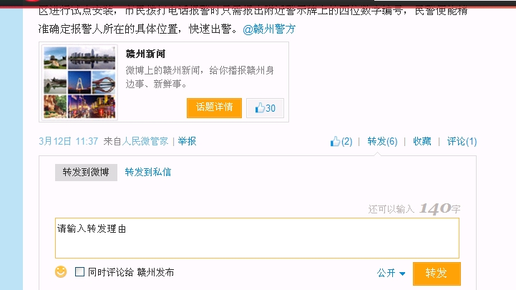

6. 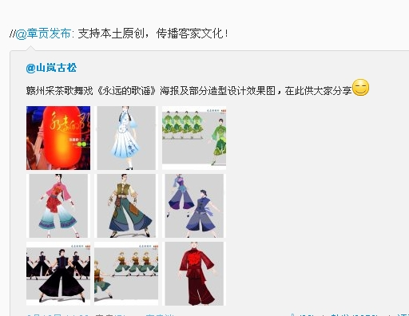
7. 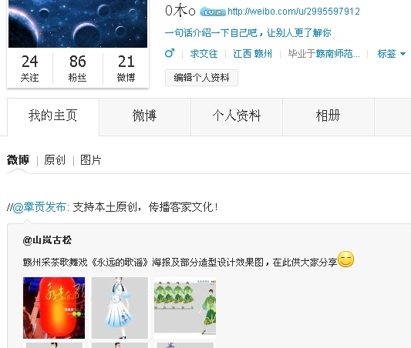
8. http://weibo.com/2607001271/profile?topnav=1&wvr=5
9. http://weibo.com/2607001271/profile?topnav=1&wvr=5
10. http://weibo.com/u/5047344384/home?wvr=5
11. 